**Calculator Assumed**

**Mixed Applications of Interval Estimates**

Time: 45 minutes

Total Marks: 45

Your Score: / 45



**Question One: [2, 2, 2 = 6 marks] CA**

The weights of 1kg bags of carrots are approximately normally distributed with a

mean of 1006 grams and a standard deviation of 5 grams.

(a) What is the probability that a randomly selected 1kg bag of carrots weighs between 1004 grams and 1008 grams?

(b) If a random sample of 50 bags are selected, what is the probability that mean weight of the bags is between 1004 grams and 1008 grams?

(c) Is the probability in (b) higher? Explain why you would expect this to occur?

**Question Two: [3, 1, 2, 2 = 8 marks] CA**

Research into the average annual salaries for school teachers in Western Australia is conducted. In a random sample the mean is found to be $72 100 and the standard deviation is found to be $8400.

(a) If the sample size was 35 teachers, calculate the 99.7% confidence interval for the mean salary.

(b) Does the margin of error increase or decrease as the sample size increases?

(c) What effect does quadrupling the size of the sample have on the margin of error?

(d) Does the confidence interval get longer or shorter as the sample size increases? Explain your answer.

**Question Three: [2, 2, 2, 2 = 8 marks] CA**

The price to earnings ratio (P/E) of stock from a random selection of 40 companies on the

Australian stock exchange (ASX) are recorded.

It is calculated that the mean is 25.2 while the standard deviation is 15.5.

(a) Calculate the 99% confidence interval for the P/E population mean for all companies listed on the ASX.

(b) How does a company with a P/E of 24 compare with the population?

(c) How does a company with a P/E of 72 compare with the population?

(d) Is it necessary to assume that the distribution of P/E is normal? Explain.

**Question Four: [1, 3, 2 = 6 marls] CA**

In a sample of 200 women it is found that 4 have an INTJ personality, as based on the Myer

Briggs personality types.

(a) Let *p* represent the proportion of all women who are considered INTJ. Find a point estimate for *p*.

(b) Find a 95% confidence for *p* and explain its meaning.

(c) Explain why for this sample, we’re not confident that our confidence interval will hold.

**Question Five: [2, 2, 2, 3, 2, 2, 1, 3 = 17 marks] CA**

At a particularly efficient bank, the time spent waiting for service is between 0 seconds and 120 seconds.

(a) Define the random variable that would model this situation.

(b) Determine the mean and standard deviation for this distribution.

Ten random samples of 50 customers each and their waiting times are recorded. The mean of each sample is given below.

55.02 52.12 66.8 61.34 53.48 64.28 52.14 61.26 52.74 69.64

(c) Calculate the mean and standard deviation of these sample means.

(d) Write down the calculator instructions you would use to calculate the mean of your own ten random simulations of 50 customers in this situation. Hence record the mean of each of your ten samples.

(e) Calculate the mean and standard deviation of your sample means.

(f) Calculate the approximate mean and standard deviation of a sample of 50 customers using your answer to (b).

(g) Comment on your answers to (c) and (f).

(h) Working with a confidence interval of 95%, determine the sample of customers required to ensure a margin of error of at most 2%.

**SOLUTIONS**

**Calculator Assumed**

**Mixed Applications Interval Estimates**

Time: 45 minutes

Total Marks: 45

Your Score: / 45



**Question One: [2, 2, 2 = 6 marks] CA**

The weights of 1kg bags of carrots are approximately normally distributed with a

mean of 1006 grams and a standard deviation of 5 grams.

(a) What is the probability that a randomly selected 1kg bag of carrots weighs between 1004 grams and 1008 grams?



 

(b) If a random sample of 50 bags are selected, what is the probability that mean weight of the bags is between 1004 grams and 1008 grams?

 

(c) Is the probability in (b) higher? Explain why you would expect this to occur?

Yes. One would expect averages of samples to have a higher probability of being close to the mean than an individual measurement.



**Question Two: [3, 1, 2, 2 = 8 marks] CA**

Research into the average annual salaries for school teachers in Western Australia is conducted. In a random sample the mean is found to be $72 100 and the standard deviation is found to be $8400.

(a) If the sample size was 35 teachers, calculate the 99.7% confidence interval for the mean salary.

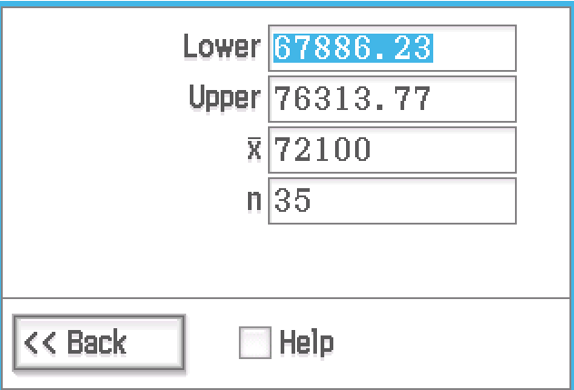 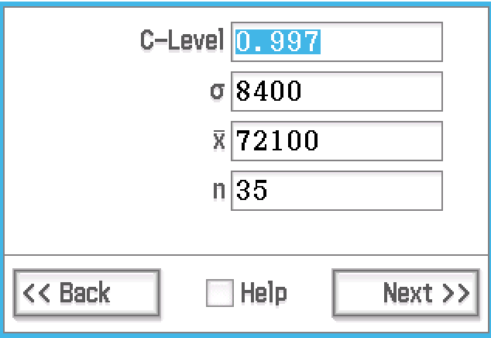



(b) Does the margin of error increase or decrease as the sample size increases?

 Decreases

(c) What effect does quadrupling the size of the sample have on the margin of error?

 The margin of error is reduced by a factor of 2 (halved) since 2 is the square root of 4.

(d) Does the confidence interval get longer or shorter as the sample size increases? Explain your answer.

 Shorter – the larger the sample size, the better the chance that it more accurately represents the population.

**Question Three: [2, 2, 2, 2 = 8 marks] CA**

The price to earnings ratio (P/E) of stock from a random selection of 40 companies on the

Australian stock exchange (ASX) are recorded.

It is calculated that the mean is 25.2 while the standard deviation is 15.5.

(a) Calculate the 99% confidence interval for the P/E population mean for all companies listed on the ASX.

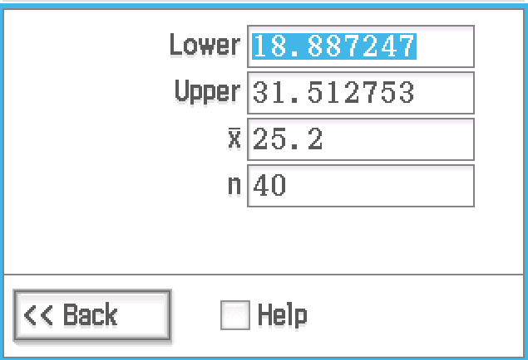

(b) How does a company with a P/E of 24 compare with the population?

 A P/E of 24 is well within the confidence interval and is probably from the same population.

(c) How does a company with a P/E of 72 compare with the population?

 A P/E of 72 is far beyond the confidence interval and is therefore unlikely to be part of this population.

(d) Is it necessary to assume that the distribution of P/E is normal? Explain.

 No it isn’t necessary since the Central Limit Theorem states that the sampling distribution will be approximately normal for sufficiently large n, and a sample of 40 is sufficiently large.

**Question Four: [1, 3, 2 = 6 marls] CA**

In a sample of 200 women it is found that 4 have an INTJ personality, as based on the Myer

Briggs personality types.

(a) Let *p* represent the proportion of all women who are considered INTJ. Find a point estimate for *p*.

 

(b) Find a 95% confidence for *p* and explain its meaning.

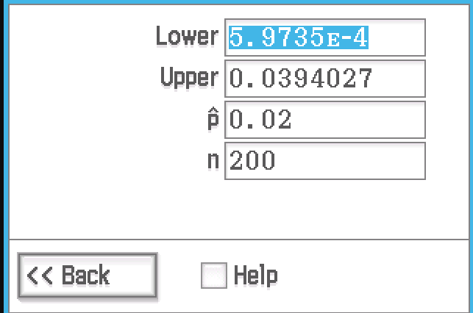 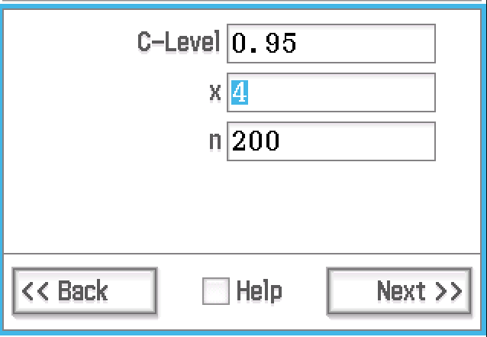



 The proportion of females who are INTJ in a sample of 200 women is likely to be between 0 and 3.9%.

(c) Explain why for this sample, we’re not confident that our confidence interval will hold.



To be confident of using this confidence interval we would need to be confident that the distribution is approximately normal. Since np < 5, we can’t be sure it will be.

**Question Five: [2, 2, 2, 3, 2, 2, 1, 3 = 17 marks] CA**

At a particularly efficient bank, the time spent waiting for service is between 0 seconds and 120 seconds.

(a) Define the random variable that would model this situation.

 

Hence, a uniform distribution

(b) Determine the mean and standard deviation for this distribution.

 

Ten random samples of 50 customers each and their waiting times are recorded. The mean of each sample is given below.

55.02 52.12 66.8 61.34 53.48 64.28 52.14 61.26 52.74 69.64

(c) Calculate the mean and standard deviation of these sample means.

 

(d) Write down the calculator instructions you would use to calculate the mean of your own ten random simulations of 50 customers in this situation. Hence record the mean of each of your ten samples.



On a ClassPad you would type in mean(randList(50, 0, 12)) and press enter 10 times.

 Your answers should be similar to those given above.

(e) Calculate the mean and standard deviation of your sample means.

 Your calculations should be close to those in part c.

(f) Calculate the approximate mean and standard deviation of a sample of 50 customers using your answer to (b).

 

(g) Comment on your answers to (c) and (f).

These answers are far closer than (b) and (f)

(h) Working with a confidence interval of 95%, determine the sample of customers required to ensure a margin of error of at most 2%.

 